Connectionless Streaming of Multimedia Content

*Instructions for exercise*

1. **Introduction**

Creating multimedia communication systems (1), including digital video libraries, access to which is done by using a telecommunications network, requires the implementation of mechanisms for streaming video sequences. Streaming is called synchronous transfer (multimedia) content from the server to the client using a telecommunications network. In this exercise, you will learn and test the processes of streaming video from servers.

1. **Objective of this experiment**

The purpose of the experiment is to learn the techniques of streaming video sequences from the server to the client computer. Video streaming software will be used for this purpose. In the following exercises will be conducting trial video server streaming. The purpose of this exercise is also to familiarize you with the techniques of streaming video sequences from the server's computer to the client computer. If the software is not installed on the computer, please download and install them (the URL in Subsection 3.2.2).

1. **Before starting the exercises**

Before performing an exercise, it is necessary to have knowledge of the basics, streaming, and preparation of the laboratory.

* 1. **Knowledge**

Prior to the course, the student should:

* Know why servers are used for streaming.
* Possess general information about the streaming server that will be used in the exercise.
* Know the basic protocols that can serve streaming media (IP (2), TCP (3), UDP (4), RTP (5)) and control multimedia streaming (RTSP) (6).
* Refer to the instructions completely.
  1. **Software**

Depending on the lab where classes are held, the appropriate software (for sending, receiving, and displaying multimedia streams) may or may not be installed on your computer. In the latter case, there is nothing to prevent the installation of software (consisting of only one application) to be conducted by you.

* + 1. **Checking installed software**

We’ll use the free program **VLC media player**. Its icon is characteristic:



In case of problems, please restart your computer. After starting the operating system, please try to run the software. If the software is missing, it is necessary to install it using the instructions below.

* + 1. **Downloading and installing the VideoLAN – VLC media player software**

To install VLC media player, you must: download the installation package from the server by saving to a folder on your local computer (remembering the place where the program is stored); to download the program, select it from the list, which is located at: [**http://www.videolan.org/**](http://www.videolan.org/) (15).

VLC media player is easy to install!

1. **Streaming content using VideoLAN Client – VLC**

Instructions below show how to proceed with the exercise. The exercise consists of several stages.

VideoLAN Client is a software developed by students of the Ecole Centrale Paris and distributed under the GNU (General Public License) out of more than 20 developers across the globe. VideoLAN is a complete solution for software streaming video. VLC can be used as a server to stream MPEG-1, MPEG-2, MPEG-4, H.264, DVD materials, etc., or live video (webcam images) to the unicast or multicast network, and may serve as a receiver, decoder and player of MPEG streams under multiple operating systems.

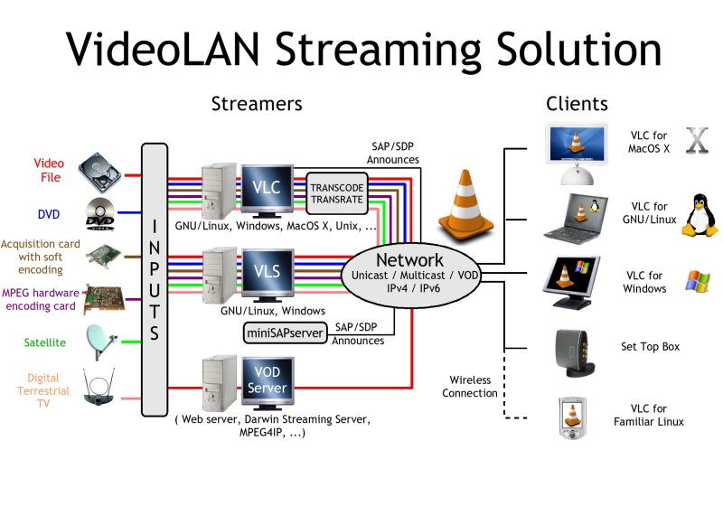

**Global solutions VideoLAN – based on (15)**

**Prior to the implementation of the exercise, the network addresses of the machine on which we conduct an exercise should be learnt (e.g., using the “ifconfig”/” ipconfig” command).**

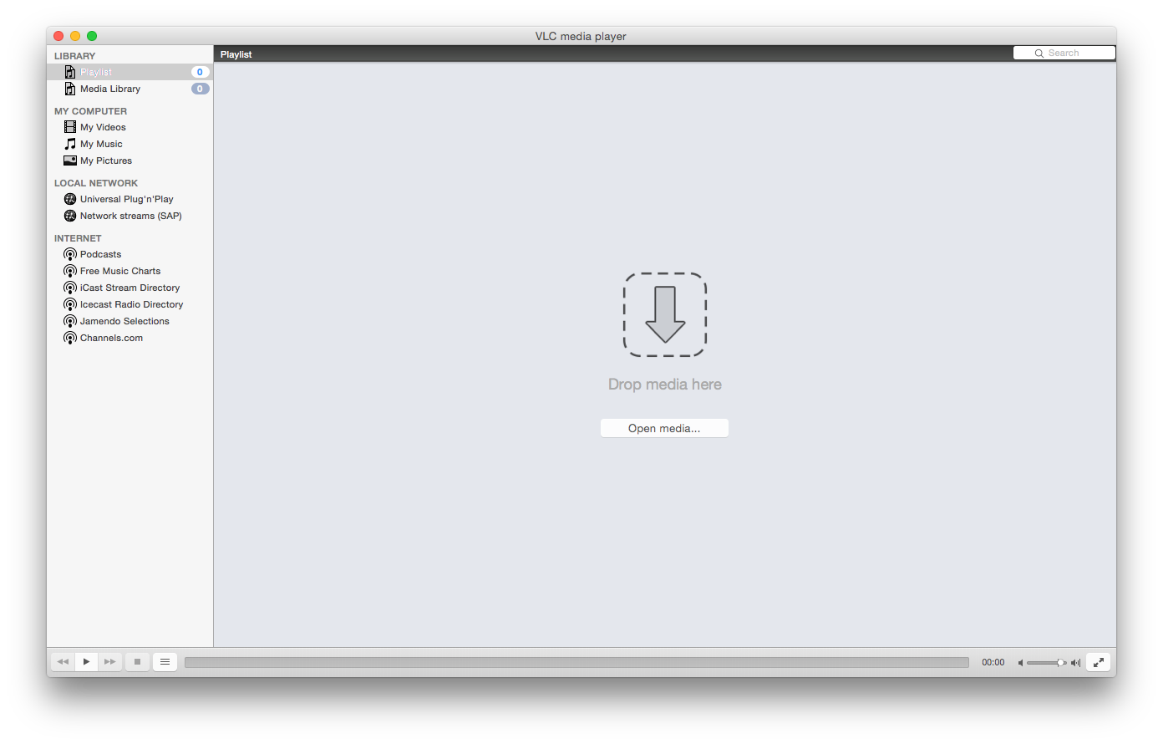

**VLC view**

* 1. **UDP streaming file**

VLC can be used as a UDP streaming server. A single stream can be sent using the GUI and advanced options while selecting the source file. To perform the exercise, it is best to use two computers. In one, we run VLC as a streaming server; the second VLC will work as a client. In addition, you will need a multimedia content. **An example of sample content is “Big Buck Bunny” (**[**http://www.bigbuckbunny.org/**](http://www.bigbuckbunny.org/)**) which download address is:** [**http://www.bigbuckbunny.org/index.php/download/**](http://www.bigbuckbunny.org/index.php/download/) **(it is recommended to use files compressed with H.264; if you experience performance issues with high-resolution video sequences, like 1080p, you may want to downgrade to lower-resolution video sequences, like 720p, 480p, 360p or even 180p). Video sequences must be downloaded to a computer that sends the media stream**.



* + 1. ***On the UDP server side (computer sending the stream)***

Operations on the UDP server side (on the computer sending the stream) can be performed using a “**Wizard**” or using **advanced settings**.

If you prefer the **Wizard**, then, on the UDP server side (the computer sending the stream), select the “File” menu, then “Streaming/Exporting Wizard…”[1] and then “Stream to the network”, and “Next”:

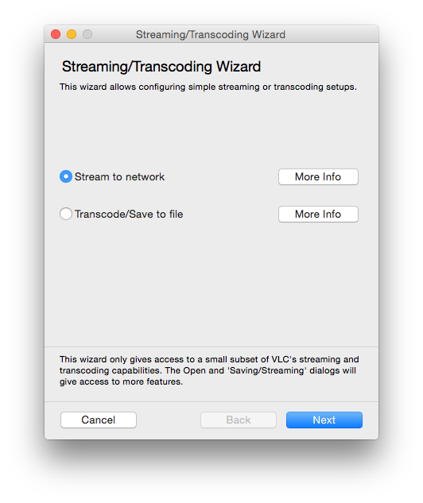

**Streaming/Transcoding Wizard**

Please do not transcode, unless you have the required codecs installed and know exactly what you are doing.

To start streaming in the window **“Choose input”**, choose **“Select a stream”**, as in the figure below:

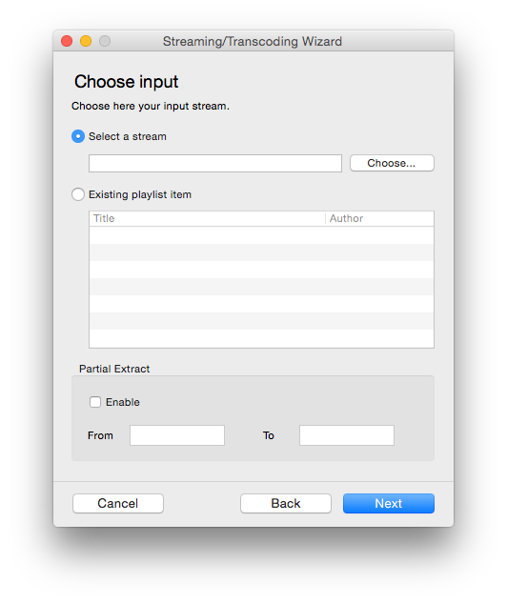

**The selection of content (video sequence)**

In the open media dialog box, you should indicate the multimedia content stored on a hard disk.

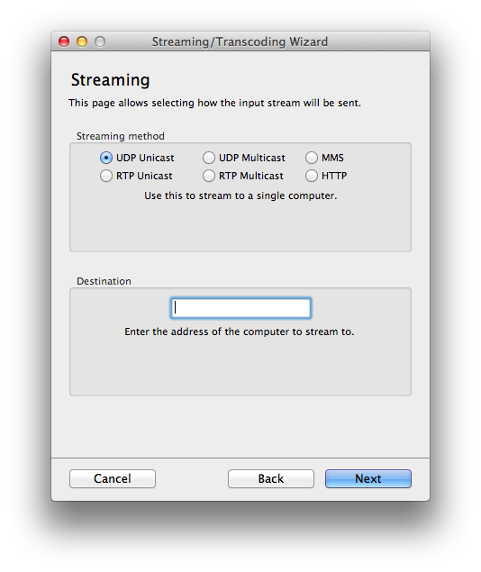

**Dialog box: “Streaming” (selection of UDP)**

In the **“Streaming”** *(figure above)* in the **“Streaming method”** select **“UDP Unicast”.** Then choose the **“Destination”** address field.

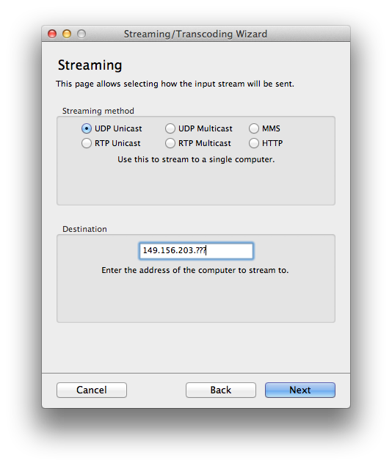

**Dialog box: “Destination” (the choice of the receiver)**

Enter the address of the computer that will **receive** the UDP stream. The Wizard sets the default port – 1234, the same port for audio and video. Other options (on the remaining windows) should be left unchanged (select **“Next”**).

After selecting the **“Finish”**,the main window will appear, and after clicking the play button, VLC Media Player is starting to take the streaming *(figure below).*

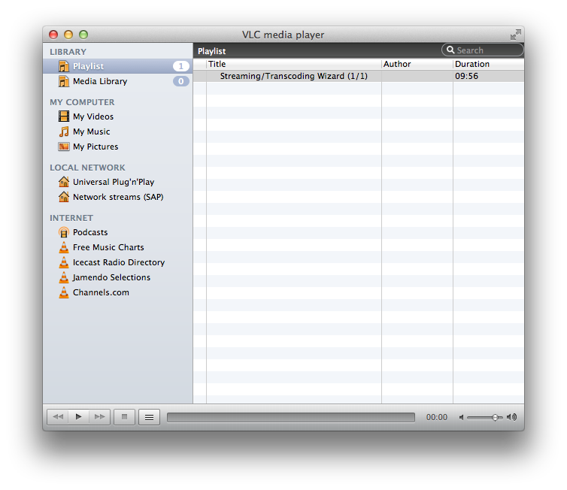

**VLC media player with streaming dialog box**

If your operating system firewall wants to block the transmission, please unlock it. At this point, we have prepared the player to send the media stream at a given address.

Alternatively, instead of using the **Wizard**, you may want to use **advanced settings** by selecting “File/Advanced Open File…”:

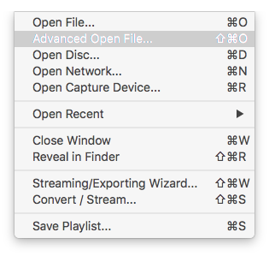

**File/Advanced Open File… ⇧⌘O**

Then, to open the source, please browse and choose a file. Next, please select to stream/save and enter the settings:

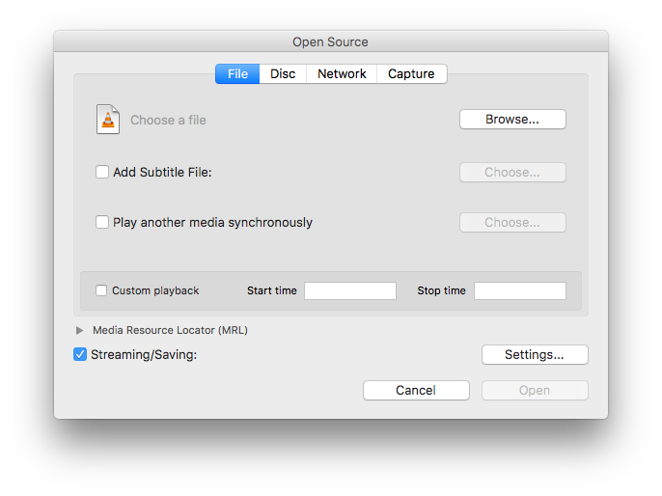

**Open Source**

Similarly, in the Wizard, select the “Stream Type”. Then enter the destination in the “Stream Address” field and confirm with the “OK” button:

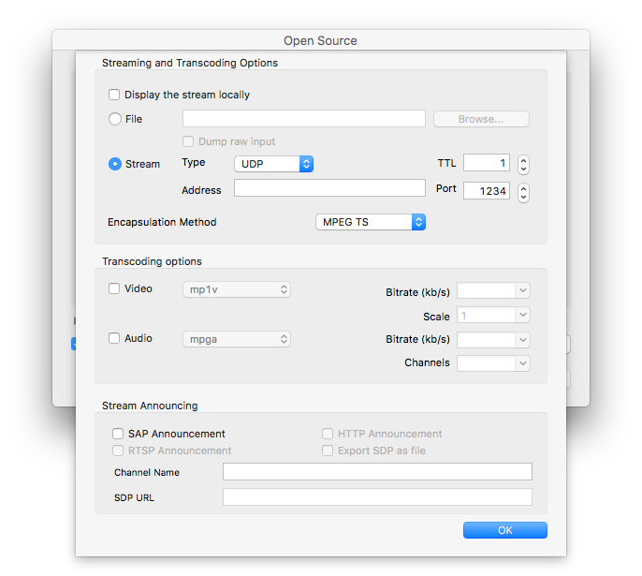

**Open Source Settings…**

The streaming will start once you click “Open” button.

* + 1. ***On the UDP client side (machine receiving the stream)***

From the **“File”** drop down menu**,** select **“Open Network”**[2], then **“Open RTP/UDP Stream”**. *Refer to the following* ***example*** *figure*:

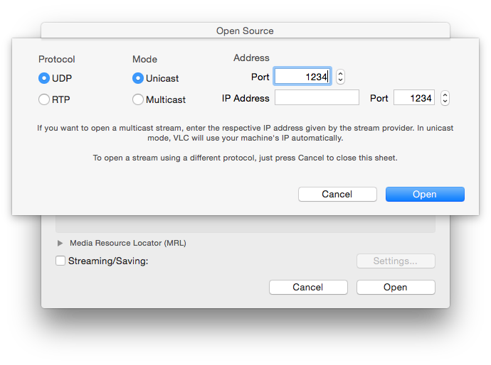

**Streaming (video sequence) multimedia content selection, dialog – opening RTP/UDP stream**

Select the protocol (the same as at the machine configured for streaming – for example, here it’s demonstrated with UDP). **In the “Port” field, please enter the port previously set on the computer that will send the stream. The port numbers set in VLC for streaming and receiving machines must be the same.**

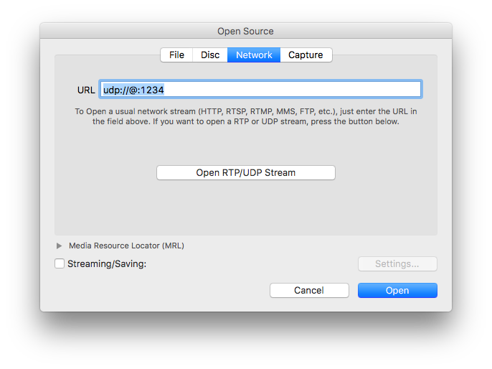

**Streaming (video sequence) multimedia content selection, dialog – opening source**

If your VLC distribution does not support “Open RTP/UDP Stream” wizard, you can also manually enter the source URL to be opened, e.g.: udp://@:1234.

* 1. **Multicast streaming file**

Please try multicast streaming from the file, using this tutorial: [28].

* 1. **Proxy from the network**

The stream, instead of being a static local file stream, can be restreamed using Wide Area Network (WAN).

For example, the server computer can pick a stream from **YouTube**. For this purpose, on the transmission side (the side of the computer working as a server), when selecting the source, select the **“Open Network…”**[3], enter the appropriate **YouTube** address, select **“Streaming/Serving”**, and in the **“Settings”** window, select **“Stream Type”** to **“UDP”**, its **“Address”** to the address of the computer that will receive the stream, and **“Port”** to **“1234”**:

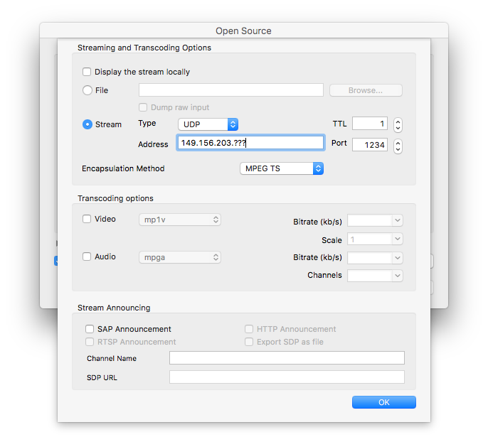

**Opening source**

Note: The source address specified on YouTube does not need to represent a **“Big Buck Bunny”** film. One can find and paste the own address.

The client computer can pick a stream from the transmission side. For this purpose, on the reception side (the side of the computer working as a client), when selecting the source, select the **“Open Network…” and** then **“Open RTP/UDP Stream”** (exactly as in the first example).

1. **Statements**

In the report (if required: by default, reports are required, the teacher can, however, decide otherwise), one should consider the significant findings and observations made in the class.

**Bibliography**

1. **Hulicki, Zbigniew.** Multimedia communication systems. Krakow. Lecture
2. **RealNetworks Inc.** Helix-Server Home Page. [Online] <https://helix-server.helixcommunity.org/>.
3. **Apple Computer, Inc.** Darwin Streaming Server Administrator’s Guide.
4. **Young Soft.** Proxy – Proxy Server Software. [Online] <http://www.youngzsoft.net/ccproxy/index.html>.
5. **Postell, J.** *Internet Protocol.* The Internet Engineering Task Force. 1981. P. 45, RFC. An updated specification of IP. Replaces RFC 760
6. *User Datagram Protocol.* The Internet Engineering Task Force. 1980s. RFCs. The specification of the UDP.
7. *Transmission Control Protocol.* The Internet Engineering Task Force., 1981. P. 85, RFC. The specification of TCP. Replaces RFCs 761 and 675.
8. **The Mplayer Project.** Mplayer – The Movie Player. [Online] <http://www.mplayerhq.hu/design7/news.html>.
9. **Apple.** Open Source – Server – Streaming Server. [Online] <http://developer.apple.com/opensource/server/streaming/index.htm>.
10. **Schulz Rinne, Henning, and others.** *RTP: A Transport Protocol for Real-Time Applications.* The Internet Engineering Task Force., 2003. P. 104, RFC. This memorandum Describes RTP, the real-time transport protocol.
11. **Schulz Rinne, Henning, Rao, Asha and LaNier, R.** *Real Time Streaming Protocol (RTSP).* Internet Engineering Task Force., 1998. P. 92, RFC. The Real Time Streaming Protocol.
12. **Apple Computer, Inc.** Apple – Public Source – Darwin Streaming Server. [Online] <http://developer.apple.com/darwin/projects/streaming/>.
13. **Apple Inc.** Apple – QuickTime – QuickTime Player. *Apple.* [Online] February 23, 2008. [Quoted February 23, 2008.] <http://www.apple.com/quicktime/player/>.
14. **RealNetworks, Inc.** New RealPlayer – [www.real.com](http://www.real.com). *Video –* [*www.real.com*](http://www.real.com)*.* [Online] February 23, 2008. [quoted: 23 February 2008.] <http://uk.real.com/player/more>.
15. **The VideoLAN Project.** VideoLAN Media Player. [Online] <http://www.videolan.org/>.https://softron.zendesk.com/entries/22255163-HOW-TO-View-an-HLS-Stream-in-QuickTime-or-VLC
16. **FFmpeg**, <https://www.ffmpeg.org/download.html>
17. **Big Buck Bunny**, <http://download.blender.org/peach/bigbuckbunny_movies/>
18. **Apple Inc.**, HTTP Live Streaming Overview, <https://developer.apple.com/library/ios/documentation/NetworkingInternet/Conceptual/StreamingMediaGuide/FrequentlyAskedQuestions/FrequentlyAskedQuestions.html>
19. **HTTP Live Streaming**, <https://tools.ietf.org/html/draft-pantos-http-live-streaming-18>
20. **OSMF HLS plugin**, <http://osmfhls.kutu.ru/>
21. “RTP: A Transport Protocol for Real-Time Applications”  
    <http://www.rfc-editor.org/rfc/rfc1889.txt>
22. Reynolds, J., and J. Postell, "Assigned Numbers", STD 2, RFC 1700, USC/Information Sciences Institute, October 1994
23. Eastlake, D., Crocker, S., and J. Schiller, "Randomness Recommendations for Security", RFC 1750, DEC, Cybercast, MIT, December 1994
24. “The ATM Forum” <http://www.atmforum.com/>
25. “Jitter – Wikipedia” <http://en.wikipedia.org/wiki/Jitter>
26. “Quality of Service – Wikipedia” <http://en2.wikipedia.org/wiki/Quality_of_Service>
27. “Asynchronous Transfer Mode – Wikipedia”, <http://en.wikipedia.org/wiki/ATM>
28. “How to use VLC Media player to stream multicast video – Peak Drive Solutions Ltd”, <https://peakdrive.com/?p=440>

1. ^W /⇧⌘W
2. ^N/⌘N
3. ^N/⌘N